Assigment

Nagendra Disamcharla

1)Git Hub URL for merge conflict work shop:

<https://github.com/nagendra0707/workshop>

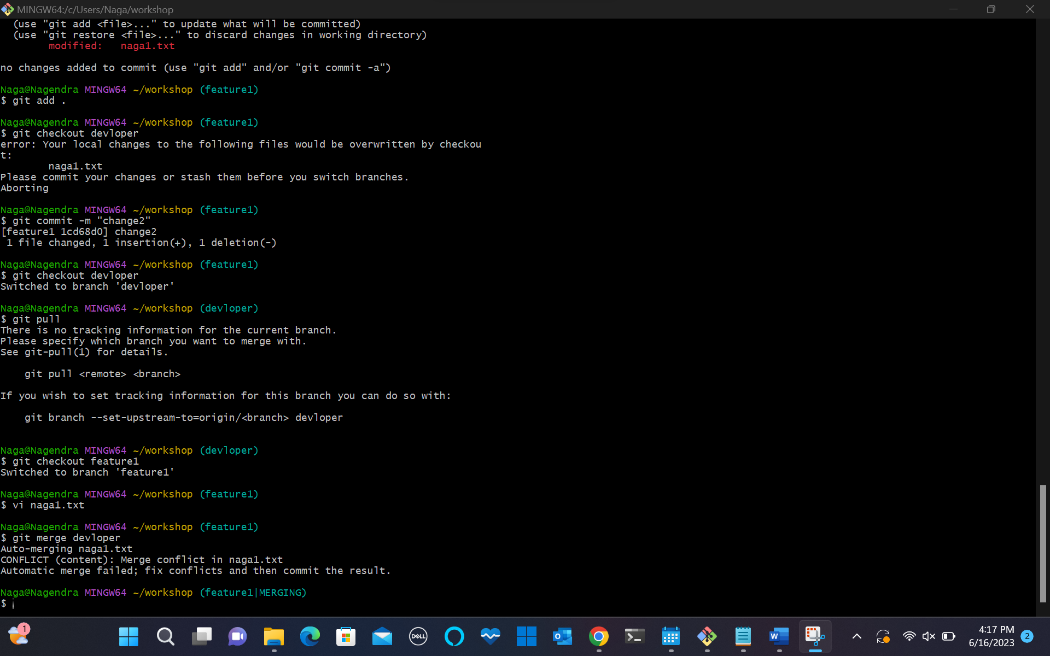

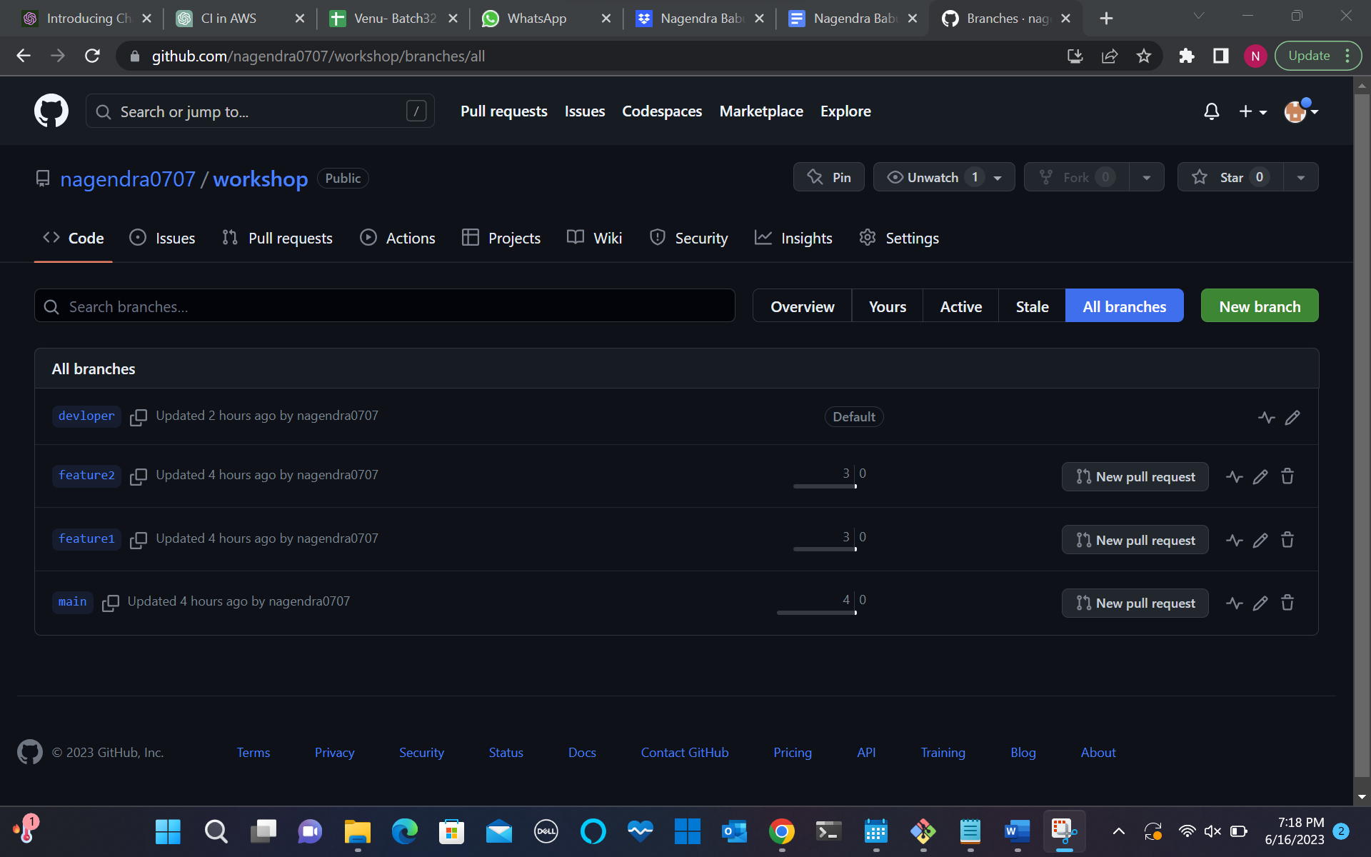

We keep both developers data:

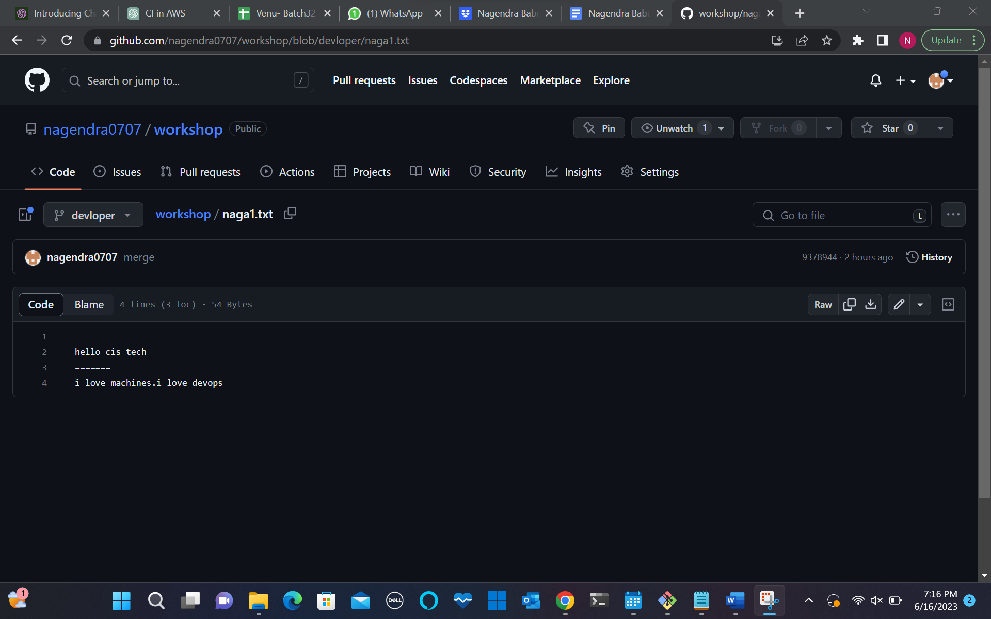

2)SSH key :

* Commands:
* Cd
* Cd .ssh
* Ssh key-gen
* ll
* Cat <.pub file_name >

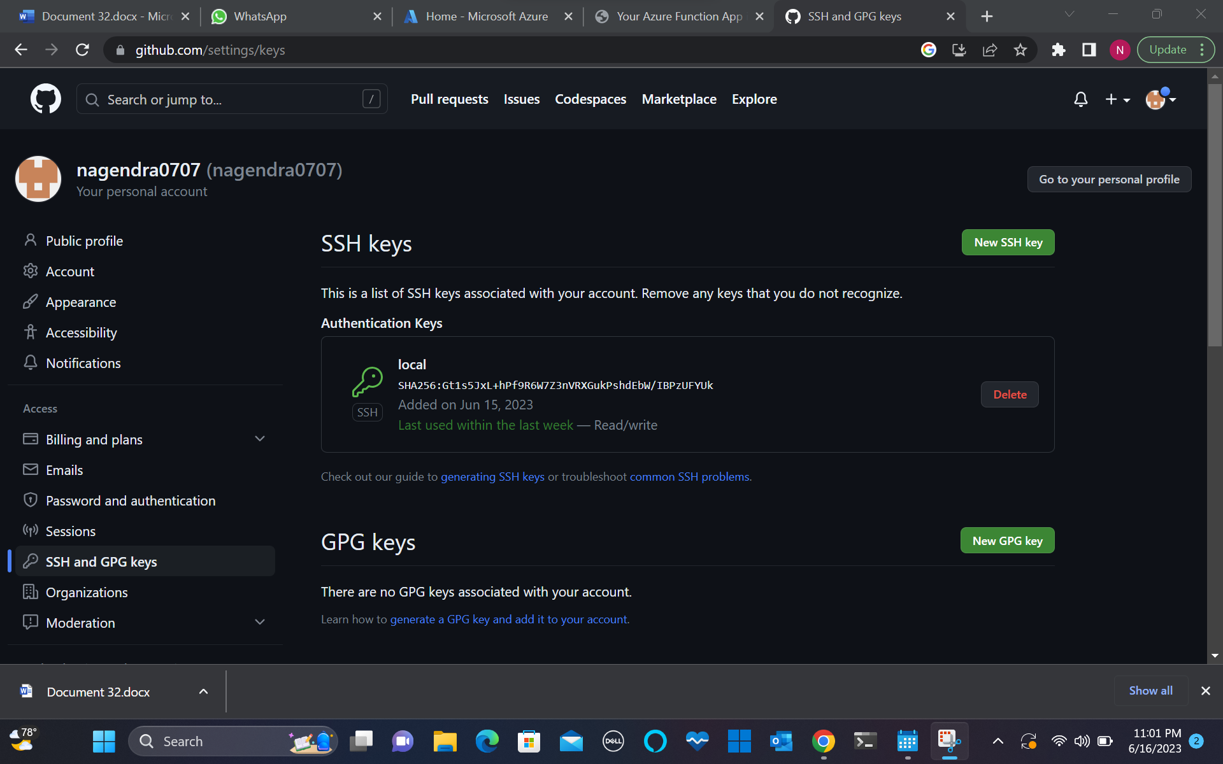

3) App Service in Azure:

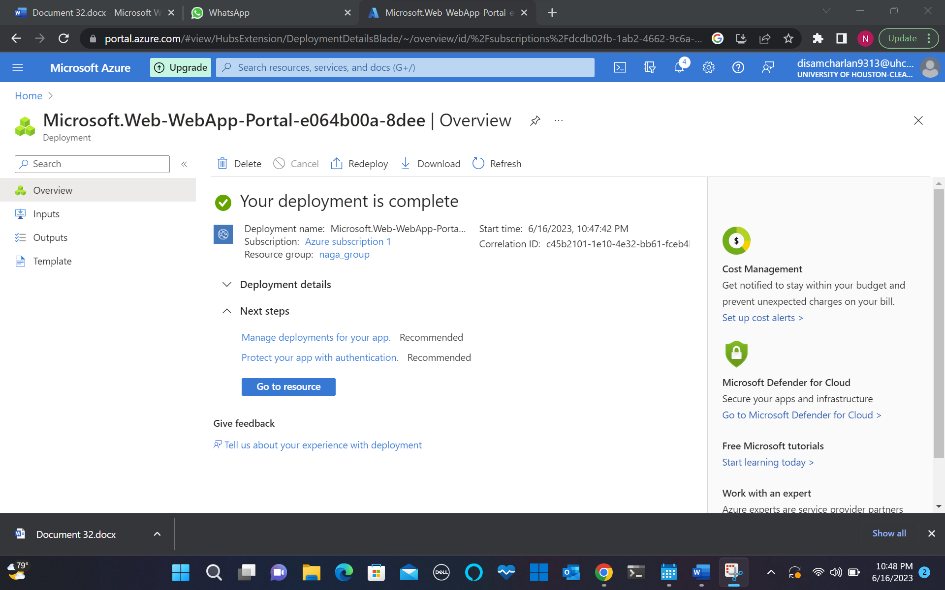

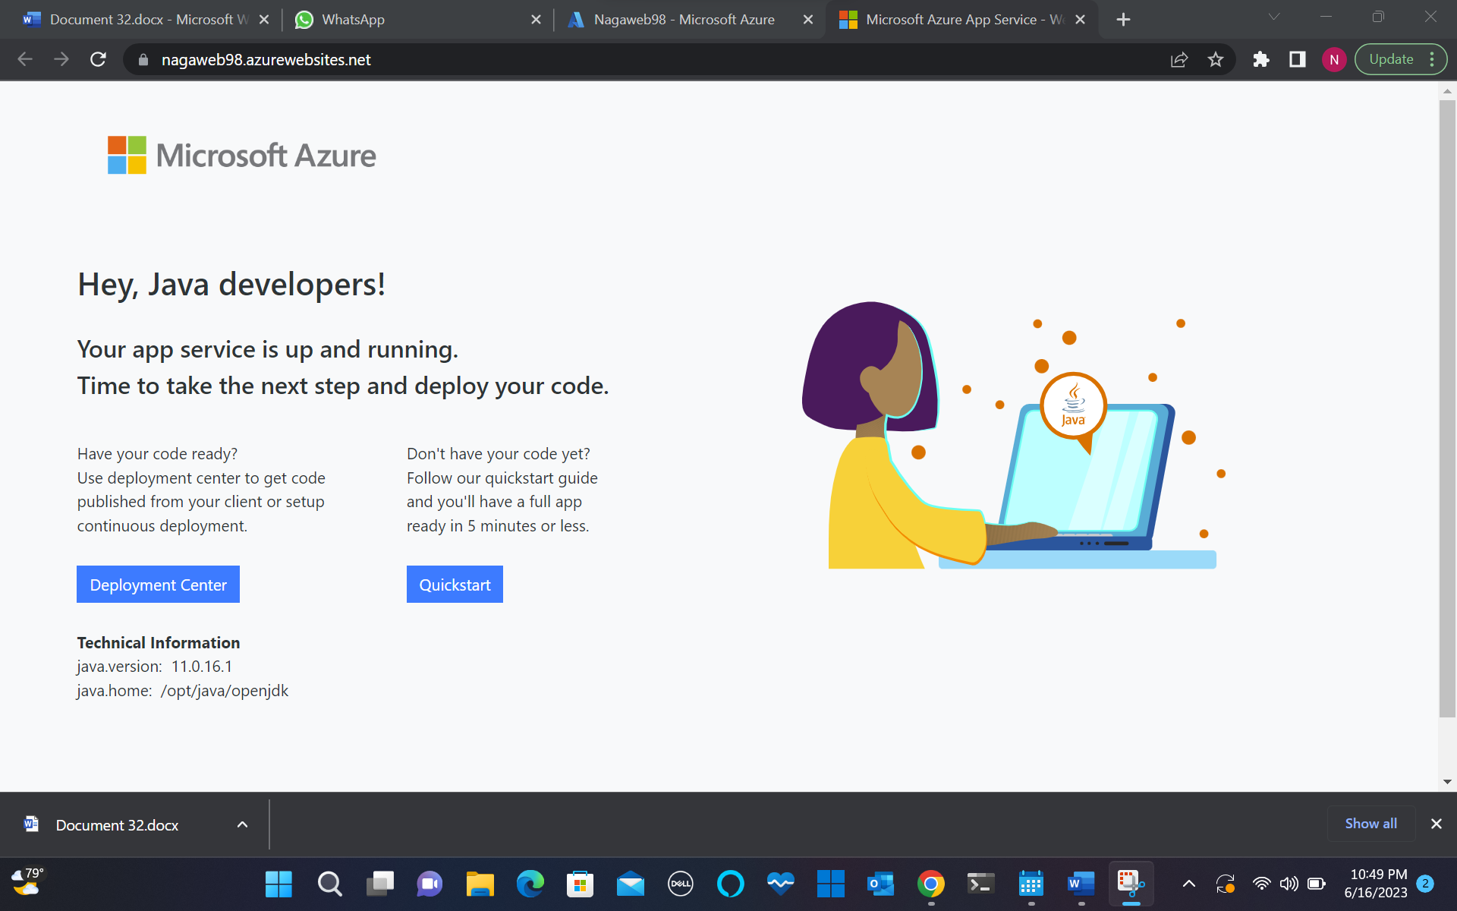

4)Function App In Azure :

